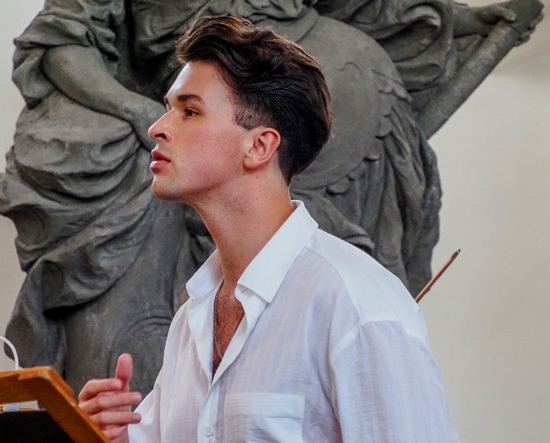
Vojtěch Pelka
Countertenor (soprano, mezzosoprano)
+420 776 204 005 vojtechpelka@gmail.com www.vojtechpelka.cz
Vojtěch Pelka is a leading countertenor of the young opera generation and a pioneer of the countertenor discipline in the Czech Republic. Known for his vocal agility and expressive dramatic performance, he graduated from the Jan Deyl Conservatory in Prague under Prof. Barbora Klozová Velehradská, with whom he continues his vocal training.
He has successfully participated in numerous esteemed international vocal competitions. His most notable achievements include the 2nd Prize and Audience Award at the 2025 Renata Tebaldi International Voice Competition in San Marino, and the Audience Award at the prestigious 2024 Cesti Competition in Innsbruck. Furthermore, he was awarded the 2nd Prize and a Special Prize for interpreting an aria by Wolfgang Amadeus Mozart at the 2019 Czech Conservatories’ Competition.
His major operatic debut came in the 2019/2020 season as Cherubino (Wolfgang Amadeus Mozart: Le nozze di Figaro) at the Silesian Theatre in Opava, a role he later presented to the Prague audience at the Estates Theatre during the Opera 2022 Festival. Shortly after, he performed Nerone (Claudio Monteverdi: L'incoronazione di Poppea) at the J. K. Tyl Theatre in Pilsen, guest-starring with this acclaimed production at the Margravial Opera House during the Musica Bayreuth Festival in 2023.
Dedicated to contemporary music, he premiered the role of Dafnis (Tomáš Hanzlík: The Treasure of Arcadia) at the 2021 Opera Schrattenbach Festival. For his extraordinary stage performance, he was nominated for the 2022 Thalia Award in the opera category. He also frequently collaborates with Michael Kocáb, performing his works such as Odysseus and Jan Hus with the Prague Symphony Orchestra FOK, the Moravian Philharmonic Olomouc, and at the Metronome Festival Prague 2024.
The 2022/2023 season brought several demanding vocal parts, including Sesto (Wolfgang Amadeus Mozart: La clemenza di Tito) presented by the Moravian Theatre Olomouc. He also achieved major international acclaim in Austria during this season, performing the role of Morasto (Antonio Vivaldi: La fida ninfa) at the widely respected Innsbrucker Festwochen der Alten Musik festival.
In 2023/2024, he formed a fruitful collaboration with the Czech ensemble Musica Florea under the direction of Marek Štryncl, singing the roles of Jupiter and Tiempo (Sebastián Durón: La guerra de los gigantes / Spanish zarzuela) for audiences in both Poland and the Czech Republic. Furthermore, he regularly sings the soprano part in Stabat mater by Giovanni Battista Pergolesi with this ensemble, a profound work he previously performed with the Slovak Sinfonietta Žilina.
During the 2024–2026 seasons, he made guest appearances at the South Bohemian Theatre, portraying the title character in the world premiere of the contemporary opera (Tomáš Hanzlík & Vít Zouhar: Pinocchio). Other notable roles from this period include Alessandro Severo (Georg Friedrich Händel: Alessandro Severo) in collaboration with Collegium Marianum at the Krumlov Festival at the unique Baroque Castle Theatre, and the role of Prenesto (Giovanni Bononcini: Il trionfo di Camilla) once again prepared with Musica Florea.
In the 2025/2026 season he returned to the J. K. Tyl Theatre in Pilsen in the title role of Tamerlano (Josef Mysliveček: Il gran Tamerlano), directed by Rocc and conducted by Vojtěch Spurný. In April 2026, he makes his highly anticipated debut at the National Theatre Brno as Nerone (Georg Friedrich Händel: Agrippina), accompanied by Collegium 1704 under Václav Luks and directed by Martin Glaser. Other major highlights of this exceptionally fruitful season include his appearance in the Les Trois Contre-Ténors! concert at the historic Royal Opera of Versailles under the baton of Stefan Plewniak, as well as a special gala evening dedicated to the works of Georg Friedrich Händel at the Warsaw Chamber Opera in Poland, accompanied by the Musicae Antiquae Collegium Varsoviense conducted by Zbigniew Pilch.
Presenting his concert and operatic repertoire to diverse audiences abroad, he performs across Germany, France, Austria, China, Poland, Switzerland, and Slovakia. He collaborates with renowned ensembles, including the Guiyang Symphony Orchestra, the Prague Symphony Orchestra (FOK), the Pilsen Philharmonic, Barocco sempre giovane, Musica Florea, Collegium Marianum, Ensemble Damian, the Moravian Philharmonic Olomouc, the RUN OPERUN association and the Viaggio musicale ensemble. He regularly gives solo recitals and appears at prominent festivals such as the Litoměřice Music Festival, Monastery Music Festival (2026 Artist in Residence), Theatrum Kuks, Opera Schrattenbach, Musica Bayreuth, Innsbrucker Festwochen der Alten Musik, Krumlov Festival and Barokowe eksploracje.
His growing discography features a 2019 CPO recording of selected arias by Ignaz Holzbauer and Jan Antonín Koželuh: Alessandro nell' India in collaboration with Ensemble 18+ and the Kurpfälzisches Kammerorchester Mannheim. In 2023, he recorded the contemporary opera The Treasure of Arcadia by Tomáš Hanzlík. Most recently, in January 2025, the CPO label released a CD of the opera La fida ninfa by Antonio Vivaldi, featuring him in the role of Morasto, again in collaboration with CPO, the OperaJung orchestra, and under the baton of Chiara Cattani.
(March 2026)

