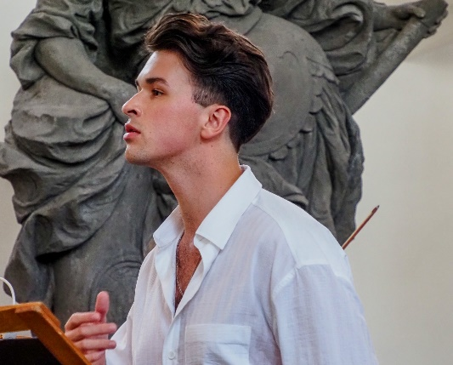
Vojtěch Pelka
Countertenor (soprano, mezzosoprano)
+420 776 204 005 vojtechpelka@gmail.com www.vojtechpelka.cz
ROLES
Tamerlano Mysliveček: Il gran Tamerlano J. K. Tyl Theatre Pilsen (CZ)
& Margravial Opera House Bayreuth (DE) 2026
Alessandro Händel: Alessandro Severo Collegium Marianum, Castle Theatre Český Krumlov (CZ) 2025
Prenesto Bononcini: Il trionfo di Camilla Musica Florea, Florea Theatrum (CZ) 2025
Pinocchio Hanzlík & Zouhar: Pinocchio South Bohemian Theatre České Budějovice (CZ) 2024
Jupiter Durón: La guerra de los gigantes Musica Florea, Florea Theatrum (CZ) 2024
Morasto Vivaldi: La fida ninfa Innsbrucker Festwochen der Alten Musik (AT) 2023
Sesto Mozart: La clemenza di Tito Moravian Theatre Olomouc (CZ) 2023
Dafnis Hanzlík: The Treasure of Arcadia Festival Opera Schrattenbach (CZ) 2021
Nerone Monteverdi: L’incoronazione di Poppea J. K. Tyl Theatre Pilsen (CZ) 2019
& Margravial Opera House (DE) 2023
Cherubino Mozart: Le nozze di Figaro Silesian Theatre Opava (CZ) 2019
Kontratenor Les Liaisons Dangereuses National Moravian-Silesian Theatre (CZ) 2018

UPCOMING ROLES
Nerone Händel: Agrippina National Theatre Brno (CZ) 2026
Orfeo Hanzlík: Cantus Mutus Orphei Festival Povaleč (CZ) 2026
Menuchim Lang: Hiob National Moravian-Silesian Theatre (CZ) 2027
Sciltalce Gluck: Metamorfosi di Semiramis Collegium Marianum, Castle Theatre Český Krumlov (CZ) 2027

SOLO CONCERTS (selection)
Tribute Concert to Emmy Destinn Rudolfinum, Dvořák Hall, Prague (CZ) 2026
From the Master’s Hand G. F. Händel Warsaw Chamber Opera (PL) 2026
Les Trois Contre-Ténors! Royal Opera of Versailles (FR) 2026
Václav Hudeček’s & Vojtěch Pelka’s Recital Barocco sempre giovanne (CZ) 2025
Vítězslav Novák: Musical Heritage Symphony Orchestra Bolech (CZ) 2025
Recital of Baroque Arias Barocco sempre giovanne (CZ) 2025
Il Natale romano Collegium Marianum (CZ) 2024
Odysseus/Jan Hus FOK Prague Symphony Orchestra (CZ) 2024
Stabat mater Musica Florea (CZ) 2024
Carmina Burana Guiyang Symphony Orchestra (CN) 2023
Stabat mater State chambre orchestra Žilina (SK) 2023
Mozart: Concert Arias Pilsen Philharmonic Orchestra (CZ) 2022
Stabat mater Czech Ensemble Baroque (CZ) 2020
Alessandro nelle Indie Kurpfälzisches Kammerorchester Mannheim, Ensemble18+ (DE) 2019

EDUCATION / TRAINING
Conservatory of Jan Deyl Prague (CZ) – teacher MgA. Barbora Klozová Velehradská 2018–2023
Masterclass with Mariusz Kwieczień (CZ) 2022, 2023
Masterclass with Simona Houda Šaturová (CZ) 2023
International Summer School of Early Music Valtice (CZ) 2018
Summer School of Baroque Music Holešov (CZ) 2017, 2018

AWARDS
Renata Tebaldi International Singing Competition in San Marino – 2nd Prize and Audience Award 2025
Cesti Competition (AT) – Audience Award 2024
Thalia Awards (CZ) – Wider nomination for the Thalia Award in the field of opera 2022
Competition of Conservatories of the Czech Republic – 2nd Prize & Special Prize for the interpretation of Mozart’s aria 2019
Dušek Singing Competition of Musical Youth (CZ) – 1st Prize 2018
International Singing Competition Olomouc (CZ) – 1st Prize & Laureate of the Competition 2018
International Competition Pro Bohemia Ostrava (CZ) – 1st Prize & Laureate of the Competition 2017

(March 2026)

